Benjamin Warren
April 27, 1944 - January 2, 2025

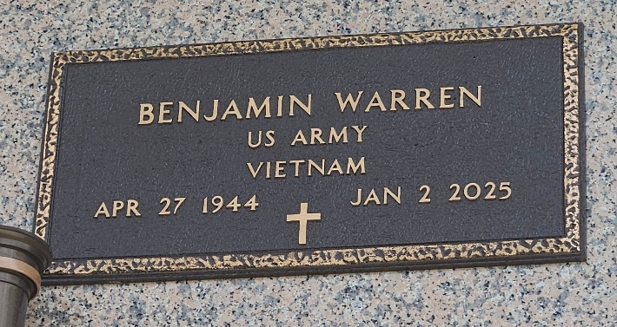
Photo by Team T-Lo

Benjamin was born April 27, 1944 to Bishop Joseph Warren, Sr. and Mary Louise Hoffman Warren. The youngest son of 11 children, he received education from Mary McLeod Bethune School in St. Charles Parish, and Carver High School in New Orleans, LA. Benjamin was a veteran and served his country under the military branch of the Army.
He was united in holy matrimony on April 1, 1972, to Verna Mae Williams Warren. From this union came three children: Corey Dale Warren, the late Jayson Arnez Warren, and Nedra Warren Richard.
Professionally, Benjamin climbed the ranks in the oil and gas industry. He was employed by Marathon Oil Company for 30 years, where he was one of the first black employees, to receive upper level training, from the company's Findlay Ohio location, an opportunity not many received at the time. He progressed from operator to senior level operator and acquired many awards during his tenure. He was a trusted and loved employee, who was asked to return to the industry to train new hires after his retirement; he accepted the task.
Benjamin was a master fisherman, who enjoyed saltwater fishing, sport fishing, fly fishing, and trolling. He caught one of south Louisiana's largest black bass and crawfish, and was featured in the Times Picayune newspaper. He possessed a large collection of rod and reels, tackle boxes, bait, and kept a fresh container of worms for each fishing trip. Many fish were preserved and are displayed in his home. Perch, sac-au-lait, bass, trout, choupique, and many other species of fish, were never safe when he was around. In the colder seasons, deer hunting was a favorite. From his catch, he would make deer sausage and patties; his process was very meticulous. He would grind the meat, season, place into casing, wrap into butcher's paper, freeze and give to anyone who wanted to eat. He would catch squirrels and make stews from them, then share It with family and friends. Hog-head cheese and cracklin were also exquisite dishes he loved to make. There was always a well kept garden in his backyard. Depending on the season and a farmer's almanac, his garden would yield fresh tomatoes, okra, mustard greens, and pepper grass. If each crop was enough to feed family and friends, he would share. His freezer was always neatly packed and filled with ziplock bags with freshly grown vegetables, fish, deer sausage, homemade gumbo and stews, with each bag labeled with a date and content for future eating.
Music was his ministry. He was a gifted guitarist who taught many, including his oldest son. He played for multiple churches, choirs, and quartet groups. He was the music manager for the gospel group, The Gospel Hymns of Joy. Under his management, the Hymns of Joy recorded music, and received successful accolades, publicity, and toured most of the Southern United States.
One of Benjamin's greatest and proudest accomplishments was building his home, by hand and from the ground up; he was a masterful carpenter. He enjoyed his home with his wife from 1982, until her passing in 2021. When he moved to Texas, he was quickly loved by the neighborhood, and met new friends who will forever remember him for giving free concerts from the garage, with his guitar and amplifier, just loud enough for the neighbors to enjoy.
He departed this life on January 2, 2025 at Memorial Hermann Hospital in Houston, Texas. He leaves to cherish his memories his children, Corey Warren, Nedra Richard, Devoted Son-In-Law, Darnell Richard, Sr., One apple of his eye, Granddaughter Neiah Darnell Richard, three loving sisters, Cloria Clark, Selena Paul, Mary Boatner, sister-in-laws Marva Joseph (Melvin), Sheryl Pierre (Alexis), Marilyn Warren (Samuel, Jr.), Joyce Bush (Michael), Marlene Watkins (Irvin), and Norma Dorris, brother-in-law, Delayed Williams, Sr., Medrick Williams, Jr., Juansley Smith, Rev. Edgar Zeno, Sr., A host of cherished nieces, nephews and friends.
He was preceded in death by his loving wife Verna Warren, son Jayson Warren, father, Bishop Joseph Warren, Sr., mother, Mary Warren, two sisters, Evola Keller, Clayola Johnson, six brother, Andrew Warren, Levi Warren, Joseph Warren, Jr., Reve. Percy Warren, Sr., Rev. Samuel Warren, Sr., and Rev. Rayfield Warren, Sr.
A celebration of life, love, and legacy will be held on Saturday, January 11, 2025, Providence Baptist Church, 240 Pine Street, LaPlace, LA 70068. Visitation begins for 9am followed by service for 10am. Entombment St. John Memorial Gardens, 2205 W. Airline Hwy., LaPlace, LA 70068.
Treasures of Life Funeral Services, Gramercy, Louisiana
January 13, 2025

